--total seats
SELECT
DISTINCT COUNT(parliament_constituency) as Total_seats
from
constituencywise_results;
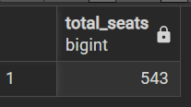
--what are the number of seats available for elections in each state
SELECT
s.states AS state_name,
COUNT(cr.parliament_constituency) AS total_seats
FROM
constituencywise_results cr
INNER JOIN statewise_results sr
ON cr.parliament_constituency = sr.parliament_constituency
INNER JOIN states s
ON sr.state_id = s.state_id
GROUP BY
s.states;
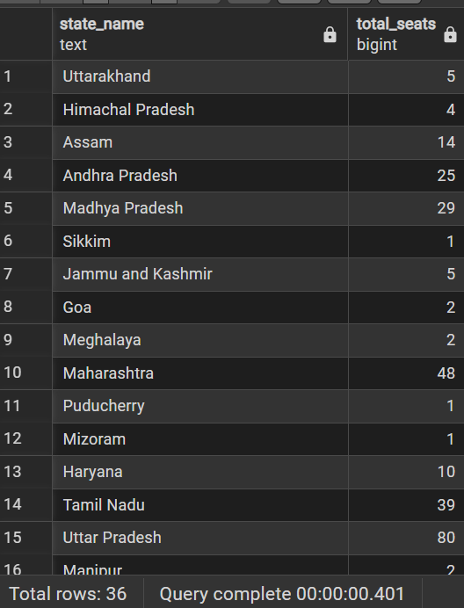
--Total seats won by NDA Allience

SELECT
SUM(CASE
WHEN party IN(
'Bharatiya Janata Party - BJP',
'Telugu Desam - TDP',
'Janata Dal (United) - JD (U)',
'Shiv Sena - SHS',
'AJSU Party - AJSUP',
'Apna Dal (Soneylal) - ADAL',
'Asom Gana Parishad - AGP',
'Hindustani Awam Morcha (Secular) - HAMS',
'Janasena Party - JnP',
'Janata Dal (Secular) - JD(S)',
'Lok Janshakti Party(Ram Vilas) - LJPRV',
'Nationalist Congress Party - NCP',
'Rashtriya Lok Dal - RLD',
'Sikkim Krantikari Morcha - SKM'

)THEN won
else 0
END) AS NDA_Total_Seats_won
from
partywise_results;


--Seats Won by NDA Allianz Parties

SELECT
party as Party_Name,
won as Seats_won
from
partywise_results
WHERE
party IN(
'Bharatiya Janata Party - BJP',
'Telugu Desam - TDP',
'Janata Dal (United) - JD(U)',
'Shiv Sena - SHS',
'AJSU Party - AJSUP',
'Apna Dal (Soneylal) - ADAL',
'Asom Gana Parishad - AGP',
'Hindustani Awam Morcha (Secular) - HAMS',
'Janasena Party - JnP',
'Janata Dal (Secular) - JD(S)',
'Lok Janshakti Party(Ram Vilas) - LJPRV',
'Nationalist Congress Party - NCP',
'Rashtriya Lok Dal - RLD',
'Sikkim Krantikari Morcha - SKM'

)
ORDER BY Seats_won DESC;
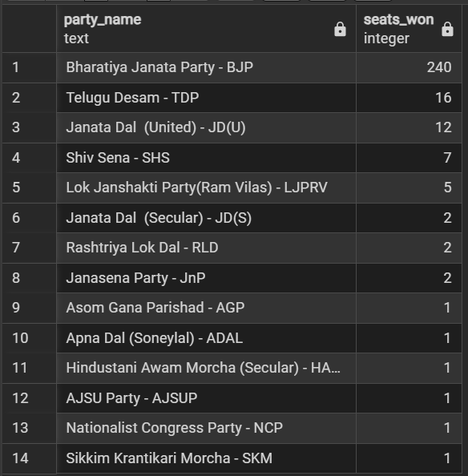

-- Total Seats Won by I.N.D.I.A.(Indian National Developmental Inclusive Alliance) Allianz

SELECT
SUM(CASE
when party IN(
'Indian National Congress - INC',
'Aam Aadmi Party - AAAP',
'All India Trinamool Congress - AITC',
'Bharat Adivasi Party - BHRTADVSIP',
'Communist Party of India (Marxist) - CPI(M)',
'Communist Party of India (Marxist-Leninist) (Liberation) - CPI(ML)(L)',
'Communist Party of India - CPI',
'Dravida Munnetra Kazhagam - DMK',
'Indian Union Muslim League - IUML',
'Nat`Jammu & Kashmir National Conference - JKN',
'Jharkhand Mukti Morcha - JMM',
'Jammu & Kashmir National Conference - JKN',
'Kerala Congress - KEC',
'Marumalarchi Dravida Munnetra Kazhagam - MDMK',
'Nationalist Congress Party Sharadchandra Pawar - NCPSP',
'Rashtriya Janata Dal - RJD',
'Rashtriya Loktantrik Party - RLTP',
'Revolutionary Socialist Party - RSP',
'Samajwadi Party - SP',
'Shiv Sena (Uddhav Balasaheb Thackrey) - SHSUBT',
'Viduthalai Chiruthaigal Katchi - VCK'
)
THEN won
ELSE 0
end) as INDIA_Alliance_Seats_won
from partywise_results;
----Seats Won by INDIA Allianz Parties

SELECT
party As Party_Name,
won AS Seats_won
FROM
partywise_results
WHERE party IN(
'Indian National Congress - INC',
'Aam Aadmi Party - AAAP',
'All India Trinamool Congress - AITC',
'Bharat Adivasi Party - BHRTADVSIP',
'Communist Party of India (Marxist) - CPI(M)',
'Communist Party of India (Marxist-Leninist) (Liberation) - CPI(ML)(L)',
'Communist Party of India - CPI',
'Dravida Munnetra Kazhagam - DMK',
'Indian Union Muslim League - IUML',
'Nat`Jammu & Kashmir National Conference - JKN',
'Jharkhand Mukti Morcha - JMM',
'Jammu & Kashmir National Conference - JKN',
'Kerala Congress - KEC',
'Marumalarchi Dravida Munnetra Kazhagam - MDMK',
'Nationalist Congress Party Sharadchandra Pawar - NCPSP',
'Rashtriya Janata Dal - RJD',
'Rashtriya Loktantrik Party - RLTP',
'Revolutionary Socialist Party - RSP',
'Samajwadi Party - SP',
'Shiv Sena (Uddhav Balasaheb Thackrey) - SHSUBT',
'Viduthalai Chiruthaigal Katchi - VCK'
)
ORDER BY Seats_won DESC;
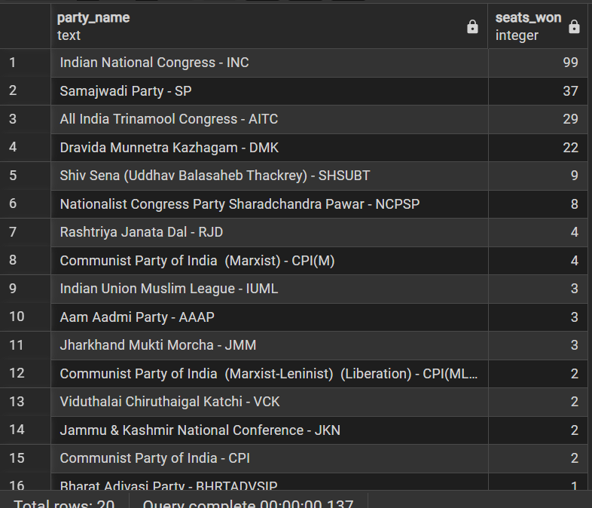

--Add new column field in table partywise_results to get the Party Allianz as NDA, I.N.D.I.A and OTHER

SELECT * FROM partywise_results;

ALTER TABLE partywise_results
ADD Party_Alliance VARCHAR(50);

SELECT * FROM partywise_results;
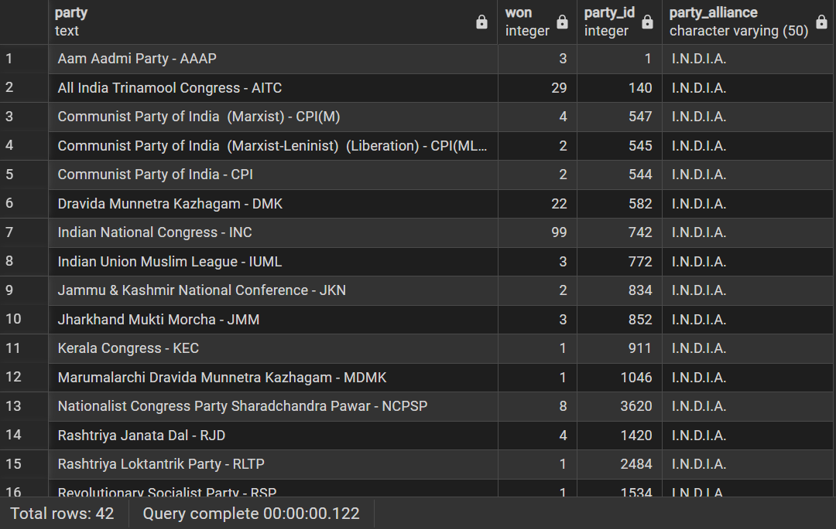
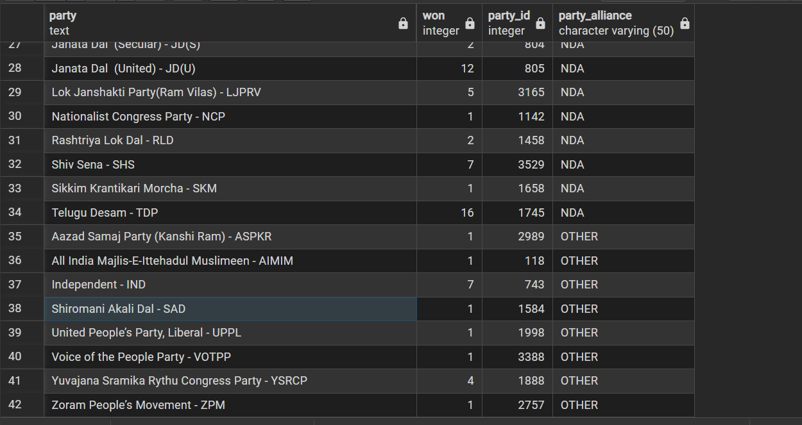
--I.N.D.I.A.

UPDATE partywise_results
SET Party_Alliance = 'I.N.D.I.A.'
WHERE party in (
'Indian National Congress - INC',
'Aam Aadmi Party - AAAP',
'All India Trinamool Congress - AITC',
'Bharat Adivasi Party - BHRTADVSIP',
'Communist Party of India (Marxist) - CPI(M)',
'Communist Party of India (Marxist-Leninist) (Liberation) - CPI(ML)(L)',
'Communist Party of India - CPI',
'Dravida Munnetra Kazhagam - DMK',
'Indian Union Muslim League - IUML',
'Nat`Jammu & Kashmir National Conference - JKN',
'Jharkhand Mukti Morcha - JMM',
'Jammu & Kashmir National Conference - JKN',
'Kerala Congress - KEC',
'Marumalarchi Dravida Munnetra Kazhagam - MDMK',
'Nationalist Congress Party Sharadchandra Pawar - NCPSP',
'Rashtriya Janata Dal - RJD',
'Rashtriya Loktantrik Party - RLTP',
'Revolutionary Socialist Party - RSP',
'Samajwadi Party - SP',
'Shiv Sena (Uddhav Balasaheb Thackrey) - SHSUBT',
'Viduthalai Chiruthaigal Katchi - VCK'
);

SELECT party,won
FROM partywise_results
where Party_Alliance = 'I.N.D.I.A.'
ORDER BY won DESC;

SELECT * FROM partywise_results;

-- NDA

UPDATE partywise_results
SET Party_Alliance = 'NDA'
WHERE party IN ('Bharatiya Janata Party - BJP',
'Telugu Desam - TDP',
'Janata Dal (United) - JD(U)',
'Shiv Sena - SHS',
'AJSU Party - AJSUP',
'Apna Dal (Soneylal) - ADAL',
'Asom Gana Parishad - AGP',
'Hindustani Awam Morcha (Secular) - HAMS',
'Janasena Party - JnP',
'Janata Dal (Secular) - JD(S)',
'Lok Janshakti Party(Ram Vilas) - LJPRV',
'Nationalist Congress Party - NCP',
'Rashtriya Lok Dal - RLD',
'Sikkim Krantikari Morcha - SKM'
)
SELECT * FROM partywise_results;

SELECT party,won
FROM partywise_results
where Party_Alliance = 'NDA'
ORDER BY won DESC;

--OTHER

UPDATE partywise_results
set Party_Alliance = 'OTHER'
where Party_Alliance IS NULL;

SELECT party,won
FROM partywise_results
where Party_Alliance = 'OTHER'
ORDER BY won DESC;

SELECT * FROM partywise_results;

--Which party alliance (NDA, I.N.D.I.A, or OTHER) won the most seats across all states?

SELECT
p.Party_Alliance,
count(cr.constituency_ID) as seats_won
from
constituencywise_results cr
JOIN
partywise_results p on cr.Party_ID = p. Party_ID
where
p.Party_Alliance IN ('NDA','I.N.D.I.A.','OTHER')
GROUP BY
p.Party_Alliance
ORDER BY
seats_won DESC;
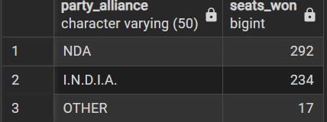

SELECT
DISTINCT COUNT(parliament_constituency)
from constituencywise_results;

--Winning candidate's name, their party name, total votes, and the margin of victory for a specific state and constituency?
SELECT
cr. winning_candidate,
pr. party,
pr.Party_Alliance,
cr. total_votes,
cr. margin,
s. states,
cr. constituency_name
FROM
constituencywise_results cr
INNER join partywise_results pr ON cr.party_id = pr.party_id
INNER JOIN statewise_results sr ON cr.Parliament_Constituency = sr.Parliament_Constituency
INNER JOIN states s ON sr.state_id = s.state_id
WHERE Party_Alliance = 'NDA' and party = 'Shiv Sena - SHS' and states = 'Maharashtra';
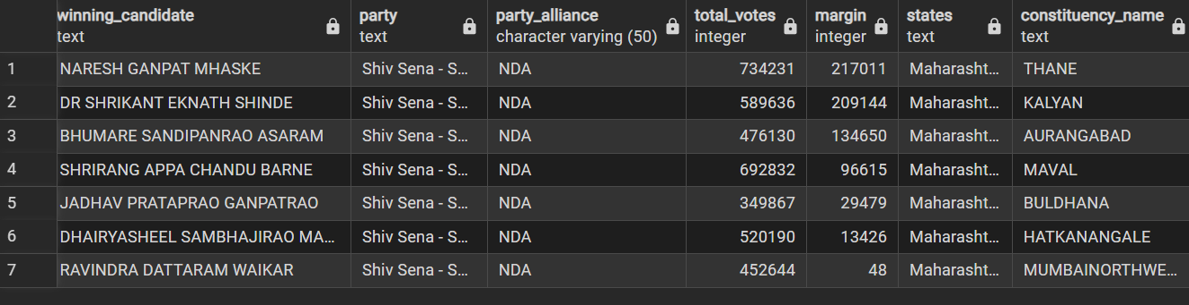
--What is the distribution of EVM votes versus postal votes for candidates in a specific constituency?

select
cd.candidate,
cd.party,
cd.evm_votes,
cd.postal_votes,
s.states,
cd.total_votes,
cr.constituency_name
FROM constituencywise_details cd
JOIN constituencywise_results cr on cd.constituency_id = cr.constituency_id
INNER JOIN statewise_results sr ON cr.Parliament_Constituency = sr.Parliament_Constituency
INNER JOIN states s ON sr.state_id = s.state_id
where party = 'Bharatiya Janata Party' and states = 'Uttar Pradesh';
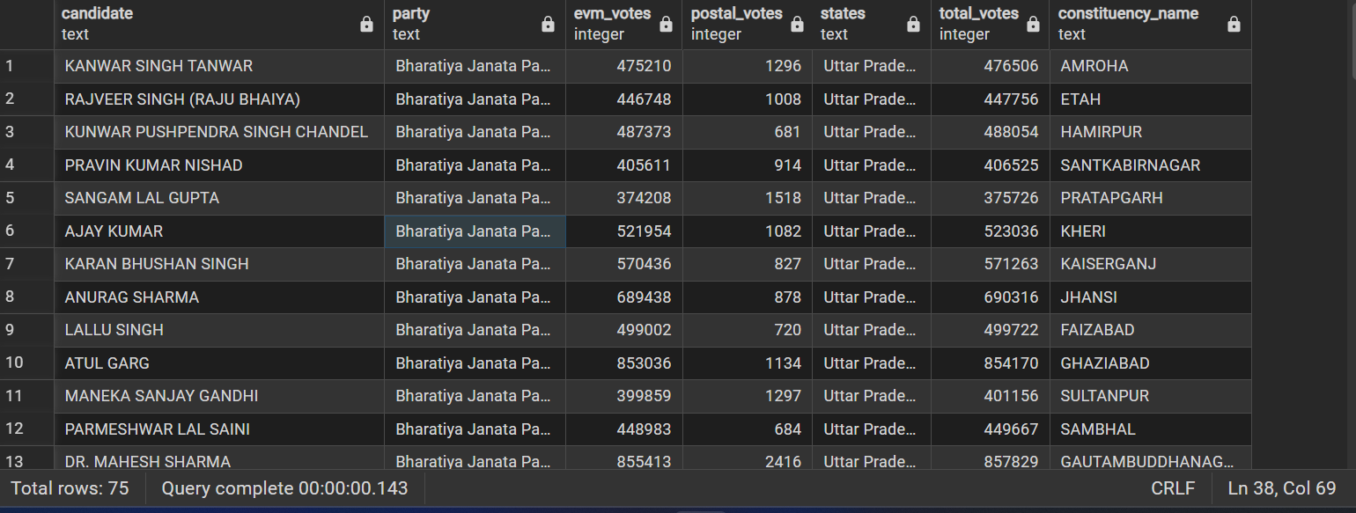
--Which parties won the most seats in s State, and how many seats did each party win?
SELECT
p.party,
COUNT(cr.constituency_id) AS Seats_Won
FROM
constituencywise_results cr
JOIN
partywise_results p ON cr.party_id = p.party_id
JOIN
statewise_results sr ON cr.parliament_constituency = sr.parliament_constituency
JOIN states s ON sr.state_id = s.state_id
WHERE
s.states = 'Bihar'
GROUP BY
p.party
ORDER BY
Seats_Won DESC;
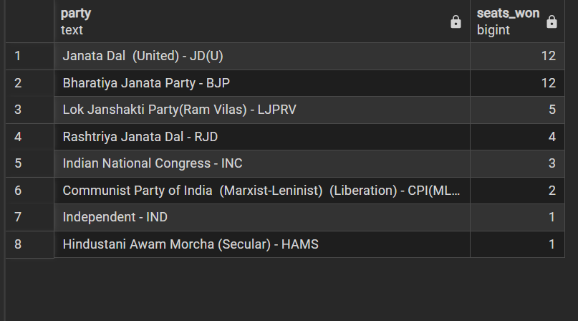
--What is the total number of seats won by each party alliance (NDA, I.N.D.I.A, and OTHER) in each state for the India Elections 2024
SELECT
s.states AS state_name,
sum(case when p.Party_Alliance = 'NDA' then 1 else 0 end) as NDA_seat_won,
sum(case when p.Party_Alliance = 'I.N.D.I.A.' then 1 else 0 end) as INDIA_seat_won,
sum(case when p.Party_Alliance = 'OTHER' then 1 else 0 end) as OTHER_seat_won
from
constituencywise_results cr
join partywise_results p on cr.party_id = p.party_id
join statewise_results sr on cr.parliament_constituency = sr.parliament_constituency
join states s on sr.state_id = s.state_id
where p.Party_Alliance in ('NDA','I.N.D.I.A.','OTHER')
group by s.states
order by s.states;
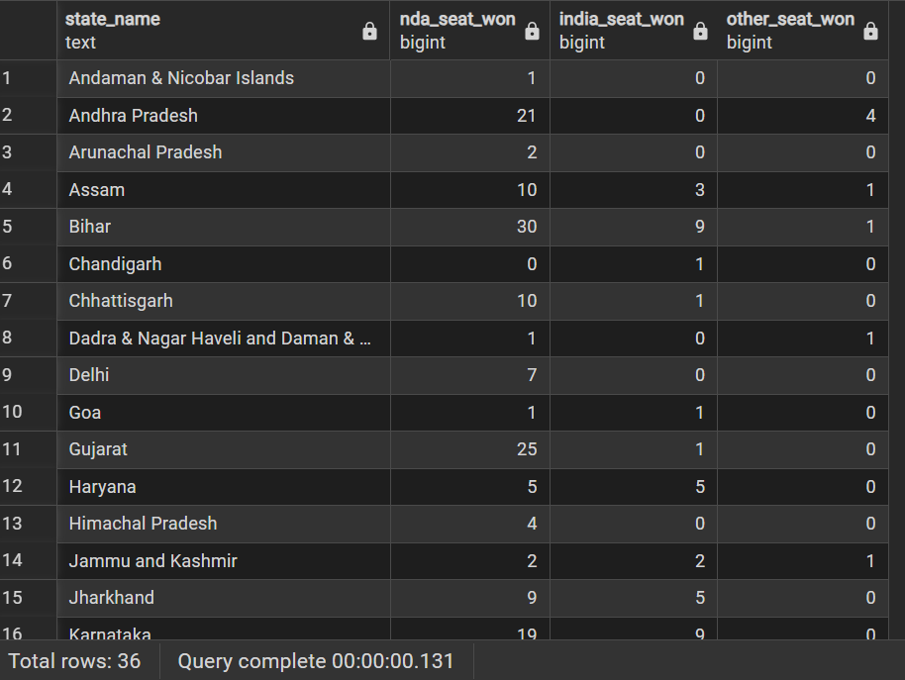
--Which candidate received the highest number of EVM votes in each constituency (Top 10)?

SELECT
cr.constituency_name,
cd.constituency_id,
cd.candidate,
cd.evm_votes
from
constituencywise_details cd
join constituencywise_results cr on cd.constituency_id = cr.constituency_id
where
cd.evm_votes =(select max(cd1.evm_votes)
from constituencywise_details cd1
where cd1.constituency_id = cd.constituency_id )
order by
cd.evm_votes desc
limit 10;

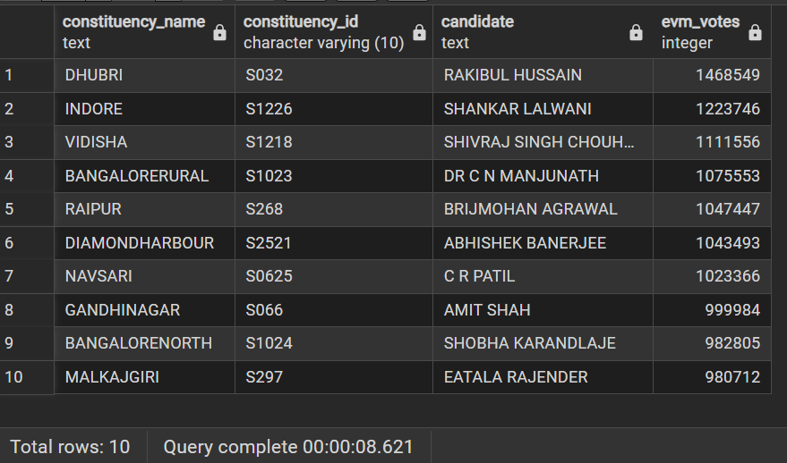
--Which candidate won and which candidate was the runner-up in each constituency of State for the 2024 elections?

with RankedCandidates as (select
cd.candidate,
cd.constituency_id,
cd.party,
cd.evm_votes,
cd.postal_votes,
cd.evm_votes + cd.postal_votes as total_votes,
ROW_NUMBER() OVER (PARTITION BY cd.constituency_id ORDER BY
cd.evm_votes + cd.postal_votes DESC ) AS VoteRank
from constituencywise_details cd
join constituencywise_results cr on cd.constituency_id = cr.constituency_id
join statewise_results sr on sr.parliament_constituency = cr.parliament_constituency
join states s on sr.state_id = s.state_id
where s.states = 'Maharashtra'
)
select
cr.constituency_name,
max(case when rc.VoteRank = 1 then rc.candidate end) as Winning_candidate,
max(case when rc.VoteRank = 2 then rc.candidate end) as Runnerup_candidate
from
RankedCandidates rc
join constituencywise_results cr on rc.constituency_id = cr.constituency_id
group by cr.constituency_name
order by cr.constituency_name;
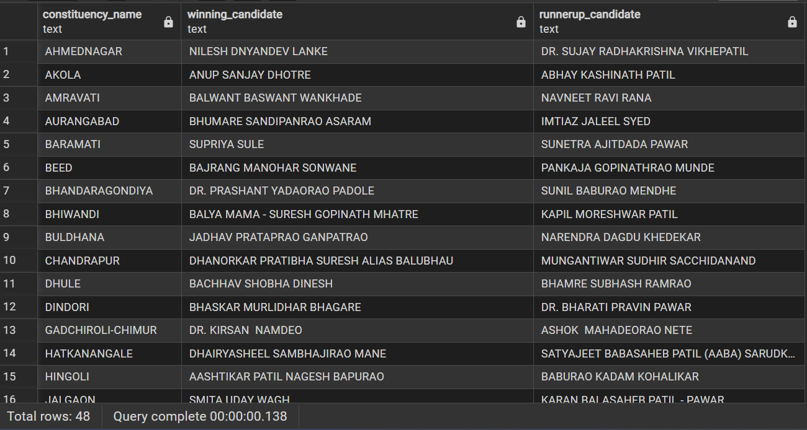
--For the state of Maharashtra, what are the total number of seats, total number of candidates, total number of parties, total votes (including EVM and postal), and the breakdown of EVM and postal votes?
select
count(distinct cr.constituency_id) as total_seats,
count(distinct cd.candidate) as total_candidates,
count(distinct pr.party) as total_parties,
sum(cd.evm_votes + cd.postal_votes) as total_votes,
sum(cd.evm_votes ) as total_evm_votes,
sum(cd.postal_votes ) as total_postal_votes
from constituencywise_results cr
join constituencywise_details cd on cr.constituency_id = cd.constituency_id
join statewise_results sr on cr.parliament_constituency = sr.parliament_constituency
join states s on s.state_id = sr.state_id
join partywise_results pr on pr.party_id = cr.party_id
where s.states = 'Maharashtra'

